**Anand Patel**

**ID: 260583812**

ECSE 321 – Assignment 3

**UML diagram of Factory for Critters:**

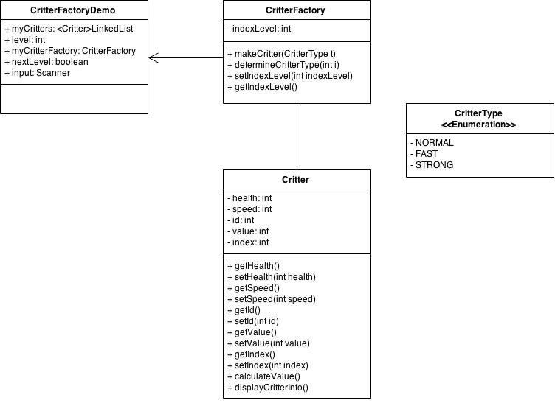

**How it works:**

The CritterFactoryDemo makes a CritterFactory. The CritterFactory usese the method makeCritter to make a critter depending on the type. This allows for dynamically adding Critter Objects during run time. The value of the attributes such as health and speed change depending on the level set by the CritterFactoryDemo. This in turn affects the value of each Critter once they die.

**Output:** (For 3 levels)

Current Level: 1

Critter Index: 0

Critter ID: 0

Health: 11

Speed: 11

Value: 22

Critter Index: 1

Critter ID: 1

Health: 11

Speed: 22

Value: 66

Critter Index: 2

Critter ID: 2

Health: 22

Speed: 11

Value: 99

Would you like to see the next round? (Y/N) : y

Current Level: 2

Critter Index: 0

Critter ID: 0

Health: 12

Speed: 12

Value: 24

Critter Index: 1

Critter ID: 1

Health: 12

Speed: 24

Value: 72

Critter Index: 2

Critter ID: 2

Health: 24

Speed: 12

Value: 108

Critter Index: 3

Critter ID: 0

Health: 12

Speed: 12

Value: 24

Critter Index: 4

Critter ID: 1

Health: 12

Speed: 24

Value: 72

Critter Index: 5

Critter ID: 2

Health: 24

Speed: 12

Value: 108

Would you like to see the next round? (Y/N) : Y

Current Level: 3

Critter Index: 0

Critter ID: 0

Health: 13

Speed: 13

Value: 26

Critter Index: 1

Critter ID: 1

Health: 13

Speed: 26

Value: 78

Critter Index: 2

Critter ID: 2

Health: 26

Speed: 13

Value: 117

Critter Index: 3

Critter ID: 0

Health: 13

Speed: 13

Value: 26

Critter Index: 4

Critter ID: 1

Health: 13

Speed: 26

Value: 78

Critter Index: 5

Critter ID: 2

Health: 26

Speed: 13

Value: 117

Critter Index: 6

Critter ID: 0

Health: 13

Speed: 13

Value: 26

Critter Index: 7

Critter ID: 1

Health: 13

Speed: 26

Value: 78

Critter Index: 8

Critter ID: 2

Health: 26

Speed: 13

Value: 117

Would you like to see the next round? (Y/N) : N

Done making Critters with Factory Pattern!